Assignment 1 – SDLC Overview
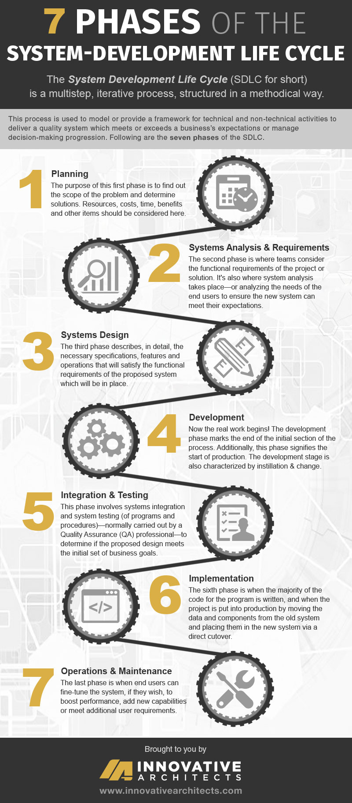
Seven Phases of the System Development Life Cycle (SDLC)
1. Planning
The SDLC begins with the planning stage, where organizations evaluate whether a new system is needed to meet strategic business goals. This phase serves as an initial feasibility assessment that examines the existing challenges and determines potential solutions. Key considerations include available resources, estimated costs, timelines, expected benefits, and organizational impact. The purpose of this phase is to clearly understand the problem’s scope and decide whether developing a new system is practical and beneficial.
2. Systems Analysis and Requirements
In this phase, teams investigate the root cause of the problem or the motivation for change. Multiple solution options are considered and reviewed to identify the most suitable one for the project’s objectives. Analysts work closely with stakeholders to document functional and non-functional requirements, ensuring that the future system will fulfill user expectations.
This step also involves tools and techniques such as:
- CASE tools (Computer-Aided Software Engineering)
- Requirements elicitation techniques
- Structured analysis methods
The outcome of this phase is a clear understanding of what the system must do and how it will serve its users.
3. Systems Design
The systems design phase converts gathered requirements into a detailed blueprint for building the system. Teams outline system architecture, physical and logical components, interfaces, data structures, network specifications, and user workflows. End users and stakeholders collaborate to clarify the essential system features and operations. By the end of this stage, the technical design clearly describes how the system will meet the defined requirements.
4. Development
This is the stage where the design is transformed into a working system. Developers write code, build databases, construct system modules, and integrate system components. Flowcharts or similar tools may be used to maintain logical consistency throughout the build process.
This phase also marks the transition from conceptual planning to actual creation. Training sessions often begin here to prepare users or technical staff for the new system.
5. Integration and Testing
Once development is complete, the system undergoes integration and thorough testing. Quality Assurance (QA) teams verify that components function correctly—both individually and as a whole. Testing cycles are repeated to identify bugs, compatibility issues, or performance gaps.
This stage includes verification (ensuring the product was built correctly) and validation (ensuring the right product was built). A system only proceeds when it meets all business and user requirements.
6. Implementation
During implementation, the fully tested system is installed in the live environment. This involves migrating data from old systems, configuring hardware or software, and performing a direct cutover or phased rollout. Because implementation carries some risk, transitions often occur during low-activity hours to minimize disruptions.
At this point, stakeholders should see the completed system operating as intended.
7. Operations and Maintenance
The final phase focuses on ensuring the system remains reliable and effective over time. Users may request improvements, additional features, or modifications to enhance performance. Routine maintenance, updates, security patches, and performance tuning take place here.
This phase is ongoing, as systems must evolve to meet changing organizational needs or technological advancements.

